

SAFEGATE: PASSWORD AUTHENTICATION SYSTEM
Course-Global Logic Building
Course Coordinator-Satya Prasad . G

2520030348-Suggula Sri Vishnupriya
2520030298-Vungarala Moukthika

1.1 EXPERIMENT OVERVIEW

The Safe Gate Password Authentication System is a security prototype designed to control access using a keypad-based password. When a user enters a password through the 4×4 keypad, the system checks whether it matches the stored password.
If the password is correct, a servo motor rotates to open/unlock the door, and the LCD display shows an “Access Granted” message. If the password is incorrect, the door remains locked and an error message is shown.
This setup demonstrates how simple electronic components like a keypad, servo, LCD, and resistors can work together to create an effective and user-friendly access control system suitable for homes, lockers, offices, and restricted areas.

1.2 OBJECTIVE
- To develop a password-based access control system using basic electronic components.
- To enable users to input a password through a 4×4 keypad for secure authentication.
- To verify the entered password with a stored password and determine access rights.
- To use a servo motor to physically open or lock the door based on the authentication result.
- To provide clear user feedback through an LCD display for correct or incorrect password entry.
- To demonstrate a simple, low-cost, and functional security prototype suitable for restricted access areas.

1.3 COMPONENTS REQUIRED
- Arduino UNO board
- LCD 16X2
- Keypad 4X4
- Micro Servo
- Connecting wires
- Resistor

1.4 SOFTWARE USED
Arduino IDE (Integrated Development Environment) for programming and uploading code to the Arduino board

1.5 THEORY

1.5.1 LCD (LIQUID CRYSTAL DISPLAY)
- An LCD is an electronic display module used to show characters, numbers, or messages.
- It works by controlling liquid crystals using electrical signals to form visible text.
- Arduino sends data to the LCD through specific digital pins using a communication protocol.
- LCDs are commonly used in embedded systems for user feedback and information display.

1.5.2 ARDUINO BOARD
- Arduino is a microcontroller-based development board used to build electronic and automation projects.
- It processes inputs from sensors or devices and provides outputs through programmed instructions.
- The board contains GPIO pins, a microcontroller chip, and a USB interface for uploading code.
- It enables easy prototyping and is widely used in education, robotics, and DIY electronics.

1.5.3 RESISTOR
- A resistor is an electronic component that limits or regulates the flow of electric current in a circuit.
- It follows Ohm’s Law, which relates voltage, current, and resistance.
- Resistors protect components from excess current or voltage.
- They are essential in Arduino circuits for ensuring safe and stable operation.

1.5.4 4X4 KEYPAD
- A 4×4 keypad consists of 16 keys arranged in a matrix of 4 rows and 4 columns.
- When a key is pressed, it connects a specific row and column, allowing the Arduino to detect the key.
- The keypad communicates with the microcontroller through digital pins.
- It is commonly used for password entry and menu navigation in embedded systems.

1.5.5 MINI SERVO MOTOR
- A mini servo motor is a small electromechanical device that rotates to a specific angle based on control signals.
- It uses a feedback mechanism and internal gears to provide precise movement, usually within 0° to 180°.
- The Arduino controls the servo by sending PWM (Pulse Width Modulation) signals to set its exact position.
- Mini servo motors are commonly used in robotics, door locks, and small mechanical projects due to their accuracy and compact size.

1.6 CIRCUIT DIAGRAM DESCRIPTION
- The Arduino Uno is connected to a 4×4 keypad, with each row and column wired to separate digital pins for detecting key presses.
- A 16×2 LCD display is connected using multiple digital pins along with two resistors to control contrast and stable operation.
- The keypad sends the entered password to the Arduino, which processes it through the programmed logic.
- A mini servo motor is connected to one of the PWM pins of the Arduino, receiving control signals to rotate when the correct password is entered.
- Power and ground lines from the Arduino supply all components, ensuring the LCD, keypad, and servo operate together in the authentication system.

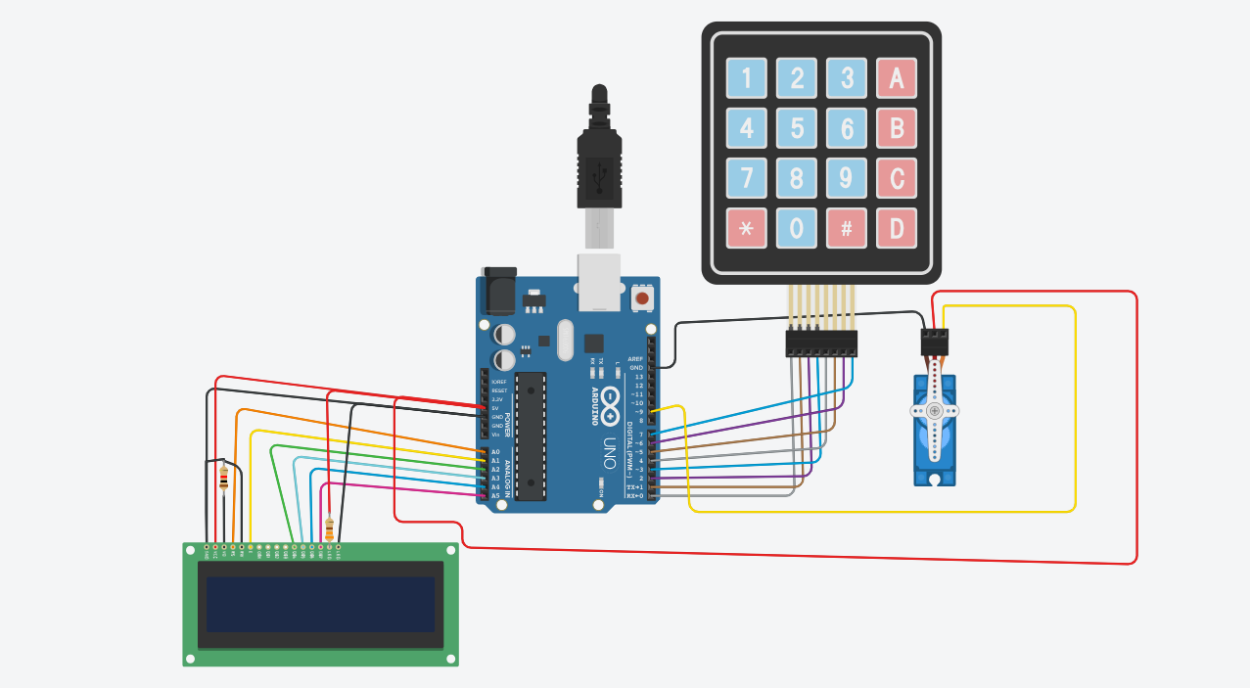

1.7 PROCEDURE
- Begin by placing the Arduino board on the workspace and connecting the 16×2 LCD. Connect the LCD’s GND pin to Arduino GND and the VCC pin to the Arduino 5V supply.
- Connect a resistor from the Vo (contrast) pin to GND to adjust the LCD contrast. Then connect RS of the LCD to pin A0, and connect RW through a resistor to GND to keep it in write mode.
- Connect the Enable (E) pin of the LCD to A1, and then connect the data pins D4, D5, D6, and D7 to A2, A3, A4, and A5 respectively. Connect two 330Ω resistors from 5V to the LCD backlight LED, and connect the LED’s negative terminal to GND.
- Connect the 4×4 keypad by wiring the row pins to digital pins 0, 1, 2, and 3, and wiring the column pins to digital pins 4, 5, 6, and 7 on the Arduino.
- Set up the servo motor by connecting its GND wire to Arduino GND, the power wire to pin 9, and the signal wire to 5V as per your circuit arrangement.
- After completing all connections, upload the Arduino program that reads keypad input, displays messages on the LCD, and controls the servo when the correct password is entered.
- Finally, power the circuit and test the operation by entering passwords on the keypad. Check that the LCD updates correctly and that the servo responds when the correct password is entered.
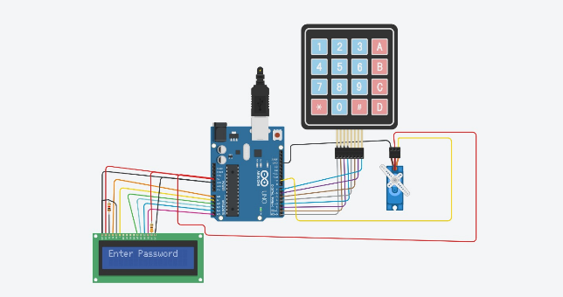
The user will enter the password on the keypad

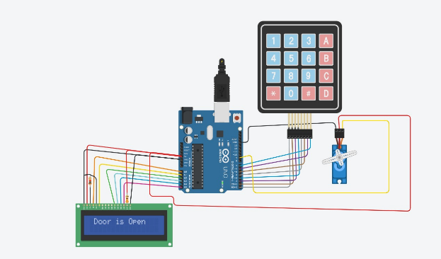

If the user enters the same password as the predefined password, then the door will
open

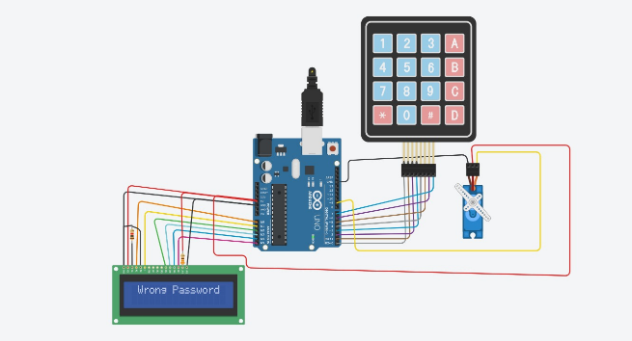
If the user enters the wrong password the door will be locked and wont open.


1.8 ARDUINO PROGRAM

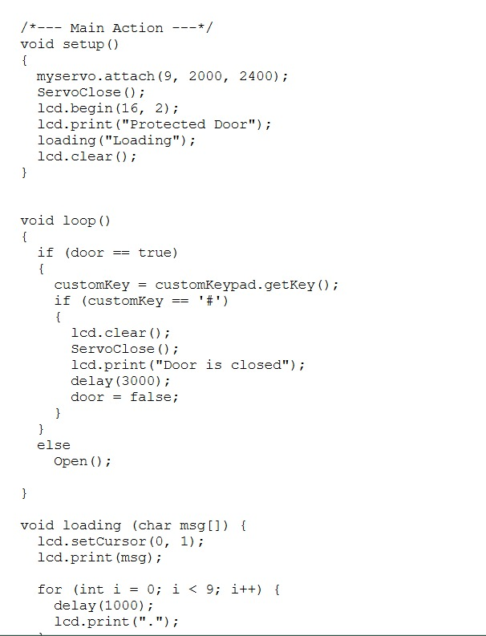

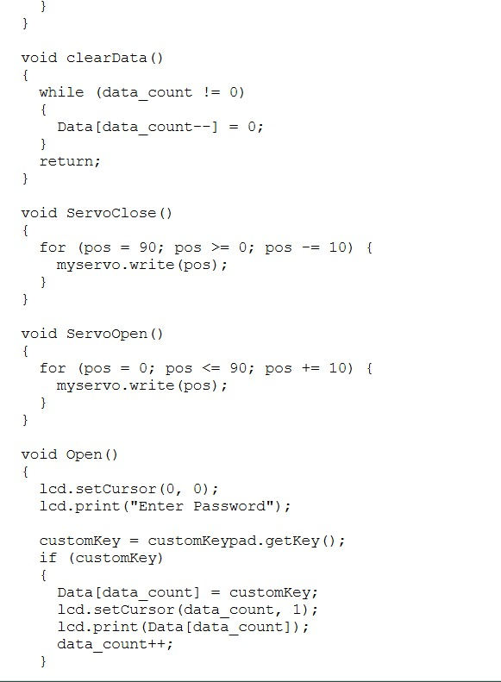

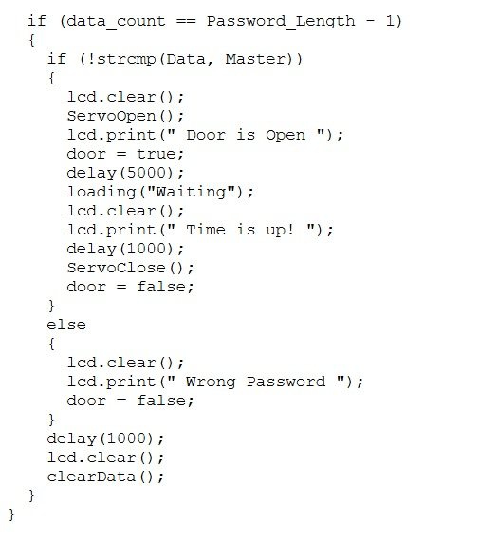

1.9 EXPECTED RESULTS
- When the system is powered ON, the LCD should display a welcome or “Enter Password” message, indicating that the system is ready.
- When keys are pressed on the 4×4 keypad, the LCD should show the entered characters or asterisks, confirming that the input is being read correctly.
- If the correct password is entered, the LCD should display “Access Granted”, and the servo motor should rotate to represent the unlocking action.
- If an incorrect password is entered, the LCD should show “Access Denied”, and the servo motor should remain in the locked position.
- The system should consistently respond to repeated inputs, showing stable LCD messages and smooth servo operation.

1.10 SELF ASSESSMENT QUESTIONS
- What components are required to build a password authentication system using Arduino?
- How does the 4×4 keypad send keypress information to the Arduino?
- What role does the servo motor play in this project?
- What happens in the system when the correct password is entered?
- What message should appear on the LCD when the password is wrong?
- Why is it important for all components to share a common GND connection?
- How does the Arduino compare the entered password with the predefined password in the program?

